**MAYAKOVSKY, Vladimir (МАЯКОВСКИЙ, ВЛАДИМИР) (1893 – 1930)**

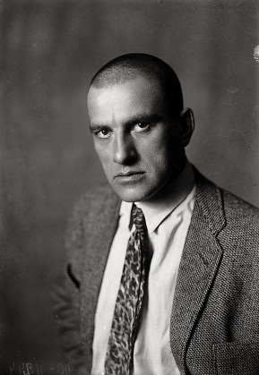Leading Russian poet of the twentieth century and representative of Russian FUTURISM, a modernist trend that emerged as an attempt to approximate the utopian future through art. Mayakovsky brought experiment and innovation to poetry, drama, cinematography and graphic design, thus changing the entire palette of Russian art. He made his literary debut in 1912 as a co-author of the scandalous Russian Futurist Manifesto *A Slap in the Face of Public Taste* (*Poshchechina obshchestvennomu vkusu*). His concern with the flagrant social injustices of the time aggravated by World War I led him to write a trilogy of early programmatic poems culminating in *A Cloud in Trousers* (*Oblako v shtanakh,* 1915). During this formative period, Mayakovsky met and fell in love with Lili Brik, a woman who would become his life-long muse and the personification of love, faith, and revolution in his oeuvre. The new aesthetic discourse he developed subsequently facilitated the poet’s passionate acceptance of the Bolshevik revolution of 1917 that promised to solve all of the tragic controversies of the past. After thirteen years of devoted service to the revolutionary ideals, he gradually became disappointed with the actual social and ethical outcomes of the revolution. This disappointment, catalyzed by his unsettled personal life, contributed to his suicide in 1930. However, in his final poem *At the Top of My Voice* (*Vo ves’ golos*, 1930), Mayakovsky does not renounce his core revolutionary values, but rather projects their implementation into the distant future, thus remaining a Futurist poet from the beginning to the end.

Mayakovsky’s photo-portrait, 1927.

**Timeline of Life and Most Significant Works:**

**1893:** Born in *Baghdadi*, Georgia, the son of a forest ranger in a family of Cossack-Ukrainian descent.

**1906:** His father dies prematurely of infection and eventually, the family moves to Moscow where the young Mayakovsky becomes involved in revolutionary activities.

**1908:** He joins the Bolshevik party and is three times imprisoned. The third, an eleven-month confinement, provides him extensive time for reading and the first experience of writing poetry.

**1911:** Enrolls in the Moscow School of Painting, Sculpture and Architecture, becomes a member of the *Hylaea* Cubo-Futurist group, and begins to regularly publish his avant-gardist verse.

**1913:** Publishes, directs and plays the leading role in the stage production of his poem *Vladimir Mayakovsky: A Tragedy (Vladimir Mayakovskii: Tragediia).*

**1915:** Meets Lili Brik, is drafted into the military service, writes several anti-war poems and satirical cycles.

**1915:** Writes and publishes three programmatic poems:  *The Backbone Flute (Fleita-Pozvonochnik),* *War and the World (Voina i mir),* and *A Cloud in Trousers (Oblako v shtanakh).* The former was inspired by and the latter dedicated to Lili Brik.

**1917:** Welcomes the Bolshevik revolution in Petrograd by publishing many passionate poetic works praising the revolution.

**1918:** Publishes the poems *Our March (Nash marsh)*, *Left March! For the Red Marines (Levyi marsh! Matrosam)*, *Good Attitude to Horses* *(Khoroshee otnoshenie k loshadyam)* and the satirical quasi-religious play *Mystery-Bouffe (Misteriia-Buff).* Produces three films based on his own scripts wherein he also plays the main roles.

**1919:** Due to his growing alienation from the Bolshevik leadership in Petrograd, the poet moves to Moscow where he participates as artist and poet in the design and production of hundreds of pro-Soviet posters.

**1922:** Produces the first draft of his autobiography *I Myself (Ia sam).*

**1922 - 1925:** Visits several foreign countries including Latvia, Germany, France, USA, Cuba, and Mexico. His travels include extremely successful poetic presentations, when he networks with the artistic elite of the West and promotes the Socialist ideas. In the same time, he also travels extensively throughout the Soviet Union.  These voyages spawn several poetic cycles and reflective essays (e.g. *My Discovery of America*) (*Moe otkrytie Ameriki*).

**1920:** Anonymously publishes his poem *150,000,000* written “on behalf” of the “collective author of revolution” - the Russian people.

**1923:** His love poem *About That* (*Pro eto*) is published at the climax of Mayakovsky’s conflict with his beloved Lili.

**1923:** Mayakovsky organizes a new futurist group LEF (*Left Front of the Arts*) and takes the lead in the group’s literary magazine of the same name.

**1924:** The poem *Vladimir Ilyich Lenin* (*Vladimir Il’ich Lenin*) is published, echoing the passing of the charismatic Communist leader in 1922.

**1925:** Publishes the poem *To Sergey Esenin* (*Sergeyiu Eseninu*) - a grieving yet life-praising response to his famous fellow-poet’s suicide.

**1926:** During his second trip to France, Mayakovsky meets and courts Tatiana Yakovleva, a young Russian émigré, who would inspire the second most notable cycle of his ecstatic love verse: *Letter from Paris to Comrade Kostrov on the Nature of Love* (*Pis’mo tovarishchu Kostrovu iz Parizha o sushchnosti liubvi*) and *Letter to Tatiana Yakovleva* (*Pis’mo Tatiane Yakovlevoi*).

**1926:** Publishes the tractate *How to Make Verse*, (*Kak delat’ stikhi*) a summary of his literary experiences.

**1927:** Publishesthe poem*Very Good!* (*Khorosho!*) – Mayakovsky’s tribute to the tenth anniversary of revolution. The concept of a correlated poem “*Very bad!*” *(Plokho!)* is simultaneously laid out but never completed

**1928 - 1929:** Publishes the bitter satirical plays *The Bedbug* *(Klop)* and *The Bathhouse* (*Bania*)

**1928:** Finalizes his autobiography *I Myself*  (*Ia sam*)

**1930:** Organizes his personal retrospective exhibition *Twenty Years of Work* (*Dvadtsat’ let raboty*) that is remarkably boycotted by the Soviet authorities

**1930**: Mayakovsky’s last work *At the Top of my Voice: First Prelude to the Poem* (*Vo ves’ golos: Pervoe vstuplenie v poemu*) is completed and would be published only after his death

**1930, April 12:** Composes a suicide note *To Everyone* (*Vsem*)

**1930, April 14:** Dies of a self-inflicted gunshot wound to the heart.

Vladimir Vladimirovich Mayakovsky (1893 - 1930), arguably one of the most prominent Russian authors of the twentieth century. A passionate supporter of Russia’s political transformation, Mayakovsky is also recognized for his tremendous role in the technical refinement and modernization of Russian literature.

Born in a province of the former Russian Empire, Mayakovsky grew up equally fluent in Russian and Georgian. This bilingualism likely contributed to his refined taste for the vocal aspect of poetry. Mayakovsky was only thirteen when his father died of an accidental infection. That loss appears to have led to a preoccupation with father figures (Alexander Pushkin, Vladimir Lenin, God) who both intimidated and attracted him.

Mayakovsky’s unique poetic world emerged from the aesthetics of Futurism. The Futurists took art, literally, “to the street” turning their poetic recitations into colorful, provocative and even scandalous performances. Mayakovsky was among the young avant-garde non-conformists who destroyed the comfortable automatism of art consumption by appearing in public with painted face or draped in a garish yellow shirt. He used unconventional rhythms and syntactic forms, neologisms and astonishing alliterations, merging the imagery of church rituals with the obscene vocabulary of the street. His talents as a graphic designer and actor were instrumental in the blending of disparate forms of art together.

The first stanza of *Listen!*

*Listen,*

*if stars are lit,*

*it means there is someone who needs it.*

*It means that someone wants them to be,*

*that someone deems those speckles of spit*

*magnificent...*

1914

Tr. Maria Enzensberger

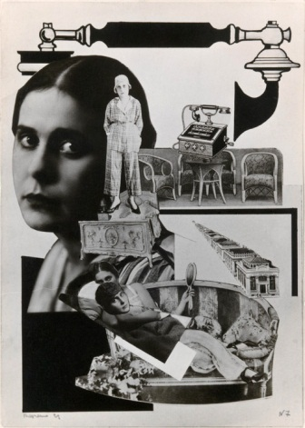

Mayakovsky enthusiastically greeted the October Revolution, confounding the Futurist artistic ideals with Bolshevik political thought and reflecting: ‘To accept or not to accept? There was no such problem for me or other Moscow Futurists. My Revolution!’ Later, Mayakovsky focused his creative energies on crafting propaganda posters for the Soviet telegraph agency (ROSTA), but his fusion of verse and visual forms, his witty and technically elaborate jingles set them apart from the primitive political propaganda of the day.

In 1923, Mayakovsky consolidated avant-gardist writers, designers, film directors and literary theorists under the banner of the LEF group (Left Front of Arts). This association and its magazine were designed to bring the Futurist agenda of ‘life-creation’ into line with post-revolutionary reality. In addition to the efforts of Mayakovsky, LEF promoted works by Viktor SHKLOVSKY, Boris PASTERNAK, Velimir KHLEBNIKOV, Sergei EISENSTEIN, Isaac BABEL, and eventually fomented the development of Russian FORMALISM and CONSTRUCTIVISM.

*Images of Lili Brik built into Alexander Rodchenko’s*

*constructivist photo-collages illustrating the first edition of the poem ‘About That’*

Mayakovsky’s late plays *The Bedbug* (1928) and *The Bathhouse* (1929)bitterly ridiculed the degenerating class of Soviet bureaucrats. Both performances were notoriously ignored by the political and literary authorities, despite the fact that their artistic perfection was reinforced by Mayakovsky’s brilliant collaborators: Vsevolod MEYERHOLD, the director, and Dmitry SHOSTAKOVICH, the composer. The same rejection followed his retrospective exhibition *Twenty Years of Work* (1929 - 1930), although it was designed to demonstrate his contribution to revolutionary art and to re-establish him as one of the founding fathers of Russian revolution.

Meanwhile, his growing social isolation was worsened by problems in his personal life. A mundane quarrel with the beautiful married actress Veronika Polonskaya provided the immediate trigger for his suicide in April 1930 but was hardly the real cause. The poet’s drastic disillusionment is evident in his final poem *At the Top of My Voice* (1930), where post-revolutionary Russian reality is remorselessly characterized as “petrified crap”.

Immediately following his death, Mayakovsky was blacklisted as a ‘bourgeois individualist’, but this changed after Stalin nominated him in 1935 as ‘the best, most talented poet of our Soviet epoch’. Soviet censorship stripped away much of his original vitality, technical ingenuity, and individualism to produce an emasculated version of Myaykovsky’s poetry which then was forcefully reintroduced into the literary mainstream as a part of the Stalinist mythology.

Mayakovsky’s legacy, though still surrounded by controversy, changed the artistic landscape of both Russia and the world. He continues to inspire new generations of authors, rock-singers, and film directors.

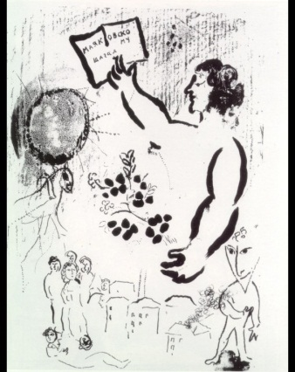                                             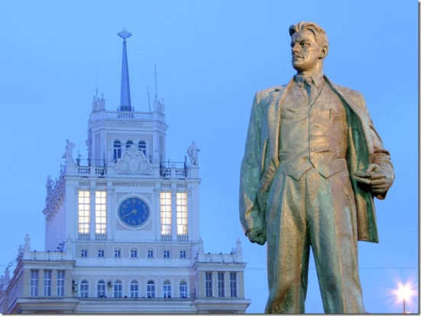

*Marc Chagall’s tribute drawing                                                    Mayakovsky’s monument in Moscow*

*for Mayakovsky’s seventieth anniversary (1963)                                        Sculptor Alexander Kibal’nikov (1958)*

**REFERENCES AND FURTHER READING**

Boym, Svetlana (1991). “The Death of the Revolutionary Poet,” in her *Death in Quotation Marks: Cultural Myth of the Modern Poet.* Cambridge, Mass.: Harvard University Press, pp. 119 – 189. A dense theoretical study that explores how the core modernist concept - “life-creation” - determines Mayakovsky’s poetic biography.  His life and death are analyzed in the wide context of the European and Russian art of the twentieth century.

Brown, Edward J (1973). *Mayakovsky: A Poet in the Revolution.* Princeton: Princeton University Press.  A classic in-depth analysis of Mayakovsky’s works focusing on his literary accomplishments rather than his biography.

Jangfeldt, Bengt (1976). *Majakovskij and Futurism, 1917 - 1921.* Stockholm: Almqvist & Wiksell. An internationally renowned Swedish researcher and biographer of Mayakovsky explores the formation and constituent elements of the poet’s Futurist style in the context of the genesis of Russian and European avant-garde.

Jakobson, Roman (1987). “On a Generation That Squandered Its Poets,” in his *Language in Literature.* Cambridge, Massachusetts. London, England: The Belknap Press of Harvard University Press, pp. 273 – 300. In this essay, written shortly after Mayakovsky’s suicide, Roman Jakobson (1896 - 1982), an outstanding literary theorist and a close friend of Mayakovsky’s, speculates about the tragic role of the generation to which the poet belonged. Written in an intelligible style, with deep understanding of all undercurrents of the literary process of the time.

Terras, Victor (1983). *Vladimir Mayakovsky*. Boston, Massachusetts: G.K. Hall & Company.

This book by Victor Terras (1921 - 2006), a prominent scholar in the field of Russian studies, is a short but comprehensive commentary on Mayakovsky’s literary work. It serves as a good introduction to the poet’s oeuvre combining an analysis of the poet’s life, major works, and his role in the Russian literature of the twentieth century.

Triolet, Elsa (2002). *Mayakovsky, Russian poet:  a memoir*. London: Hearing Eye.  The elder sister of Lili Brik, a close friend of Mayakovsky’s, and a wife of the French poet Louis Aragon, Elsa Triolet (1896 - 1970) provides a very personal insight into Mayakovsky’s private life. Despite its rather emotional impressionistic style, this book vividly recounts the intellectual milieu of pre- and post-revolutionary Russia.

**Natalia Krylova, American Councils for International Education**

URL’s TO ILLUSTRATIONS:

Figure 1 (Mayakovsky, 1927) - <http://mlkshk.com/r/51JB>

Figure 2 (Lili / Rodchenko) - <http://os.colta.ru/m/photo/2011/06/03/3-2.jpg?attempt=1>

Figure 3 (Marc Chagall) - <http://uploads6.wikipaintings.org/images/marc-chagall/drawing-by-marc-chagall-for-vladimir-mayakovsky-s-70th-birthday-1963.jpg>   
  
Figure 4 (Mayakovsky’s monument / Arch. Kibal’nikov) - <http://lifeglobe.net/media/entry/353/1601490_3.jpg>